**Guacamole Screen video-recording**

**Step-1** : First do some changes in connection settings:

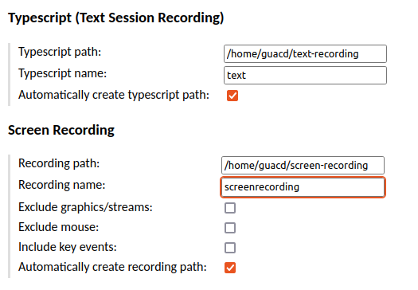

**Step-2** : Now save it and check inside the container after starting the session.

Go inside the guacamole container :

================================

**podman exec -it guacamole-guacd bash**

================================

**Step-3** : Change Directory where the files are being generated :

**guacd@guacamole:/$ cd home/guacd/screen-recording**

**guacd@guacamole:~$ ls**

**screenrecording**

Note : Directory where the recordings are being copied from **guacamole-guacd** container to base machine $/home/mansi/screen-recording/

**Step-4 :** Make a container of guacenc by using below mentioned command with mounting the same directory of recorded files:

=============================

**podman run -d -v '/home/mansi/screen-recording/':'/videos' --name guacenc bytepen/guacenc**

=============================

**Repository : docker.io/bytepen/guacenc:latest**

Sample Output :

+++++++++++++++++

mansi@mansi-HP-EliteBook-840-G3:~/screen-recording$ podman run -d -v '/home/mansi/screen-recording':'/videos' --name guacenc bytepen/guacenc

✔ docker.io/bytepen/guacenc:latest

Trying to pull docker.io/bytepen/guacenc:latest...

Getting image source signatures

Copying blob 69d5f65ddb5e done

Copying blob d550c1da08cc done

Copying blob 05c89299c7d1 done

Copying blob 1f42175256b9 done

Copying blob 4675c4be9a5b done

Copying config 3eb7dc06f5 done

Writing manifest to image destination

Storing signatures

ed34553ab56d3d08bc5ea9d9e1dc99445a59a2797575722ec3a11b27eff5089b

+++++++++++++++++++

**Step-5 :** Check the container using the below mentioned command.

mansi@mansi-HP-EliteBook-840-G3:~/screen-recording$ podman ps

ed34553ab56d docker.io/bytepen/guacenc:latest /bin/ash /usr/loc... 7 seconds ago Up 7 seconds ago guacenc

**Step-6 :** Go inside the **guacenc** container :

mansi@mansi-HP-EliteBook-840-G3:**~/screen-recording$ podman exec -it guacenc /bin/ash**

**Step-7 :** Change Directory where the files are being copied :

/# cd /videos

/videos # ls

screenrecording

**Step-8 :** Encode the screenrecoding file to screenrecording.m4v by using below mentioned command:

**/videos/screen-recording # guacenc screenrecording**

**Sample-Output :**

guacenc: INFO: Guacamole video encoder (guacenc) version 1.3.0

guacenc: INFO: 1 input file(s) provided.

guacenc: INFO: Video will be encoded at 640x480 and 2000000 bps.

guacenc: INFO: Encoding "screenrecording" to "screenrecording.m4v" ...

guacenc: INFO: All files encoded successfully.

/videos # ls

screenrecording screenrecording.m4v

/videos/screen-recording #

**Step-9 :** Now exit from the container using ctrl+d

**Step-10 :** And copy the files from **guacenc** container by using below mentioned command :

$podman cp guacenc:/videos/screen-recording .

**Step-11 :** Now try to play this recorded video by VLC Media Player.

Here is the Output:

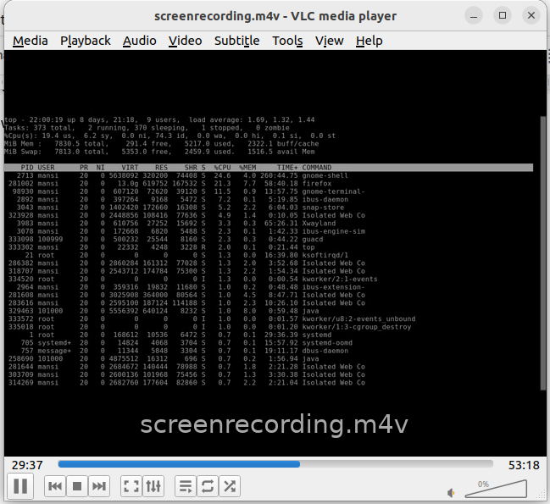

**Link I followed for solving this :** [**https://www.reddit.com/r/docker/comments/w633an/screen_recording_in_apache_guacamole/**](https://www.reddit.com/r/docker/comments/w633an/screen_recording_in_apache_guacamole/)